**Data DESCRIPTION**

The data was collected by ourselves. We have made 16 paper helicopters with different parameters including paper type, rotor length, leg length, leg width, and paper clip on leg. Detailed description of these parameters can be found in VARIABLES and Assembly Instructions parts. We chose a wide and closed interior to test fly these 16 paper helicopters one by one in order to ensure the final experimental results will not be disturbed by external factors.

**VARIABLES**

|  |  |  |  |
| --- | --- | --- | --- |
| Variables | Description | Type | Level |
| RunOrder | Run order number | Continuous | 80 |
| Trail Number | Replicate experiment for a same paper helicopter | Continuous | 1-5 |
| Paper Type | Paper type | Categorical | 1 - light  2 - heavy |
| Rotor Length | Rotor length (long & short) | Categorical | 1 - 6 cm  2 - 8 cm |
| Leg Length | Leg length (long & short) | Categorical | 1 - 8 cm  2 - 12 cm |
| Leg Width | leg width(long & short) | Categorical | 1 - 3 cm  2 - 5 cm |
| Paper Clip  on Leg | There is a Paper Clip  on Leg or not | Categorical | 1 - Yes  2 - No |
| Flight Time | The time it stay in the air | Continuous | Range from 1.22cm to 2.30cm |

**Assembly Instructions**

Step 1: Cut the paper to a width of 5cm.

Step 2: Cut the paper the length of paper rotor length plus leg length, and add 2 cm for the body.

Step 3: Cut dotted lines at Leg A and Leg C. The length of each cut is 5 cm minus leg width divided by 2.

Step 4: Fold leg A onto leg B.

Step 5: Fold leg C onto leg B.

Step 6: Fold rotor A and rotor B in opposite directions. They should form 90° to the body and be 180° away from each other.

Step 7: For the paper clip version: Add a paper clip to the bottom of the leg

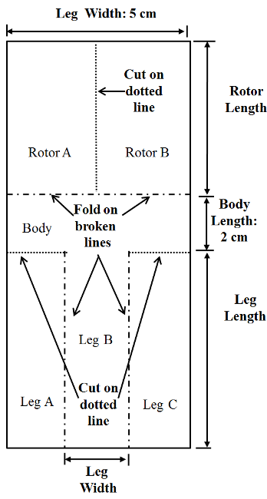

**Figure 7.1 : The helicopter plan**

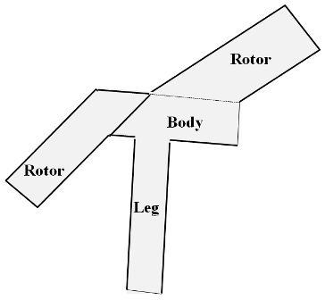

**Figure 2: The finished helicopter**